Assignment A3

Analysis and Design Document

Student: Raul-Mihai Acu

**Group: 30432**

Table of Contents

1. Requirements Analysis 3

1.1 Assignment Specification 3

1.2 Functional Requirements 3

1.3 Non-functional Requirements 3

2. Use-Case Model 3

3. System Architectural Design

3.1 Architectural Pattern Description 3

3.2 Diagrams 5

4. Class Design 5

4.1 UML Class Diagram 4

5. Data Model 6

6. System Testing 6

7. Bibliography 7

1. Requirements Analysis

# Assignment Specification

The objective of this assignment is to implement a client-server architectural style application to manage a news agency.

# Functional Requirements

● The application must be client-server.

● Use the Observer design pattern for updating the list of articles in real time

● For sending data from the client to the server use JSON serialization.

● When writing an article, show a list that supports multi-select for choosing the related articles.

# Non-functional Requirements

• Accessibility and Usability – the application will have as targets all kinds of users.

• Readability – the code needs to be easily understood by other programmers, have a good naming convention.

• Security and Privacy

2. Use-Case Model

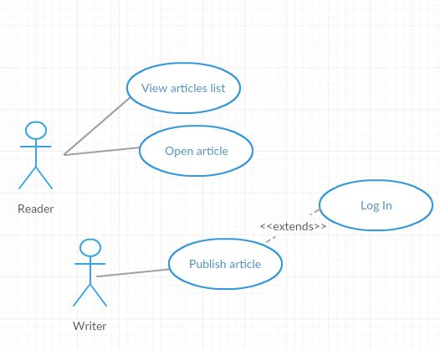

• Use case: Publish a new article

• Level: User-goal level

• Primary actor: Writer

• Main success scenario: The writer logs in and writes an article, then publishes it.

• Extensions: The writer tries to log in, but provides wrong password and no access is granted.

The article has bad input.

3. System Architectural Design

**3.1 Architectural Pattern Description**

**Layered architecture**

Components within the layered architecture pattern are organized into horizontal layers, each layer performing a specific role within the application. Although the layered architecture pattern does not specify the number and types of layers that must exist in the pattern, most layered architectures consist of four standard layers: presentation, business, persistence, and database

**Client/server architecture**

This type of architecture has one or more client computers connected to a central server over a network or internet connection. This system shares computing resources.

Client/server architecture is also known as a networking computing model or client/server network because all the requests and services are delivered over a network.

4. Class Design

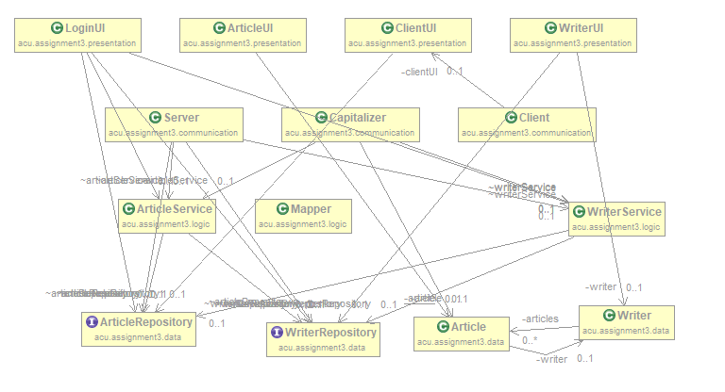

**Packages Diagram**

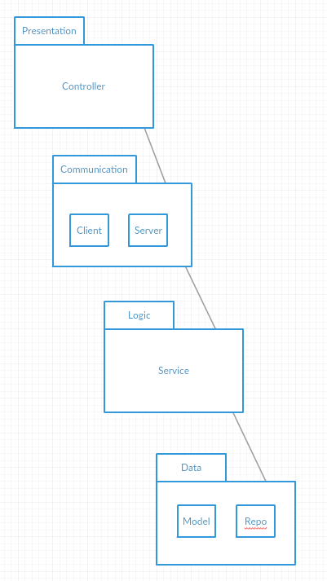

5. Data Model

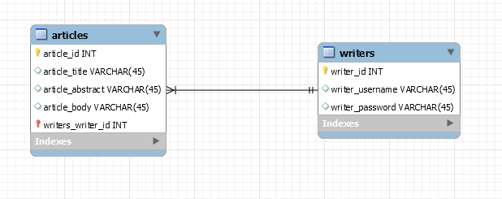

6. System Testing

• **Unit testing** is a software testing method by which individual units of source code, sets of one or more computer program modules together with associated control data, usage procedures, and operating procedures, are tested to determine whether they are fit for use.

• **Graphical user interface testing** is the process of testing a product's graphical user interface to ensure it meets its specifications. This is normally done through the use of a variety of test cases. To generate a set of test cases, test designers attempt to cover all the functionality of the system and fully exercise the GUI itself.

**• Usability testing** is a technique used in user-centered interaction design to evaluate a product by testing it on users. Setting up a usability test involves carefully creating a scenario, or realistic situation, wherein the person performs a list of tasks using the product being tested while observers watch and take notes (dynamic verification).

7. Bibliography

<https://msdn.microsoft.com/en-us/library/ee658109.aspx>

<https://www.oreilly.com/ideas/software-architecture-patterns/page/2/layered-architecture>

<https://en.wikipedia.org/wiki/System_testing>